**SECTION 2: Guess the Output**

Snippet 1:

public class NestedLoopOutput {

public static void main(String[] args) {

for (int i = 1; i <= 3; i++) {

for (int j = 1; j <= 2; j++) {

System.out.print(i + " " + j + " ");

}

System.out.println();

}

}

}

// Guess the output of this nested loop.

Output :

1 1 1 2

2 1 2 2

3 1 3 2

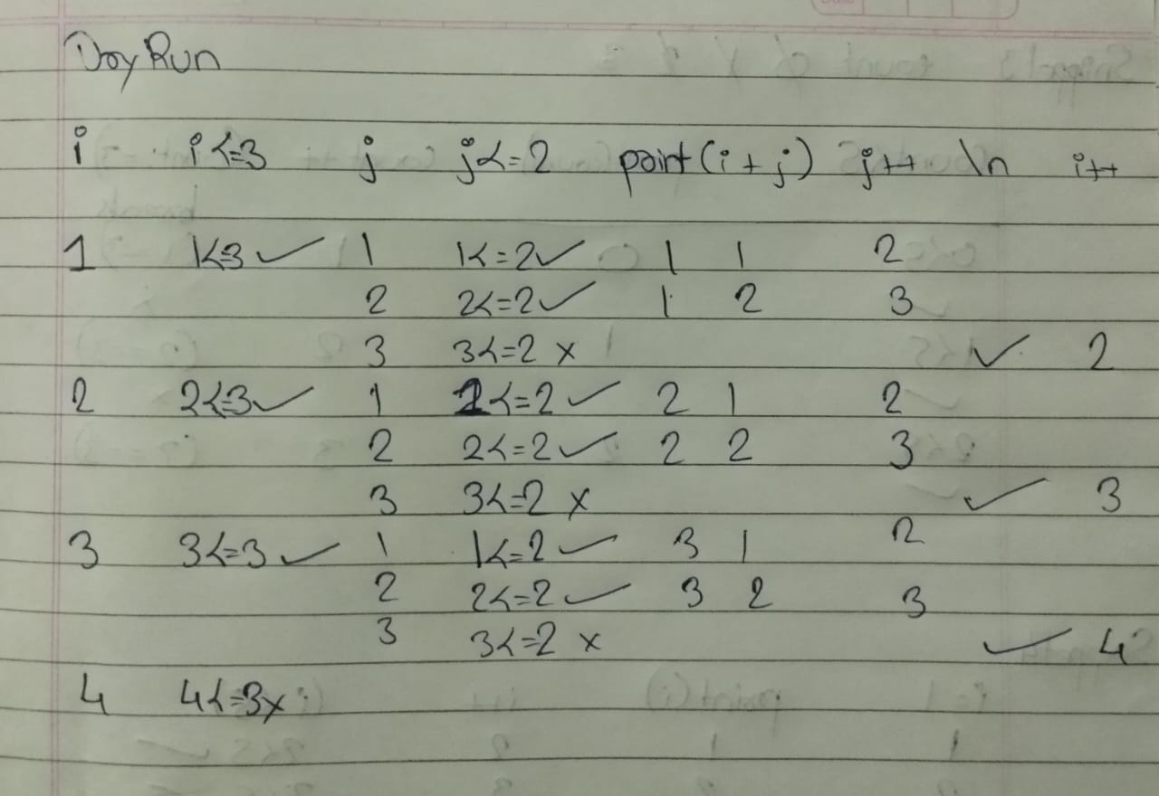

**Snippet 2:**

public class DecrementingLoop {

public static void main(String[] args) {

int total = 0;

for (int i = 5; i > 0; i--) {

total += i;

if (i == 3)

continue;

total -= 1;

}

System.out.println(total);

}

}

// Guess the output of this loop.

// **output : 11**

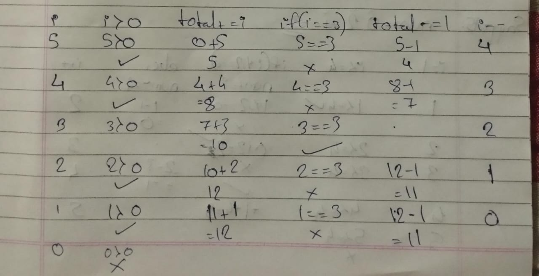

**Snippet 3:**

public class WhileLoopBreak {

public static void main(String[] args) {

int count = 0;

while (count < 5) {

System.out.print(count + " ");

count++;

if (count == 3)

break;

}

System.out.println(count);

}

}

// Guess the output of this while loop.

**Output** : 0 1 2 3

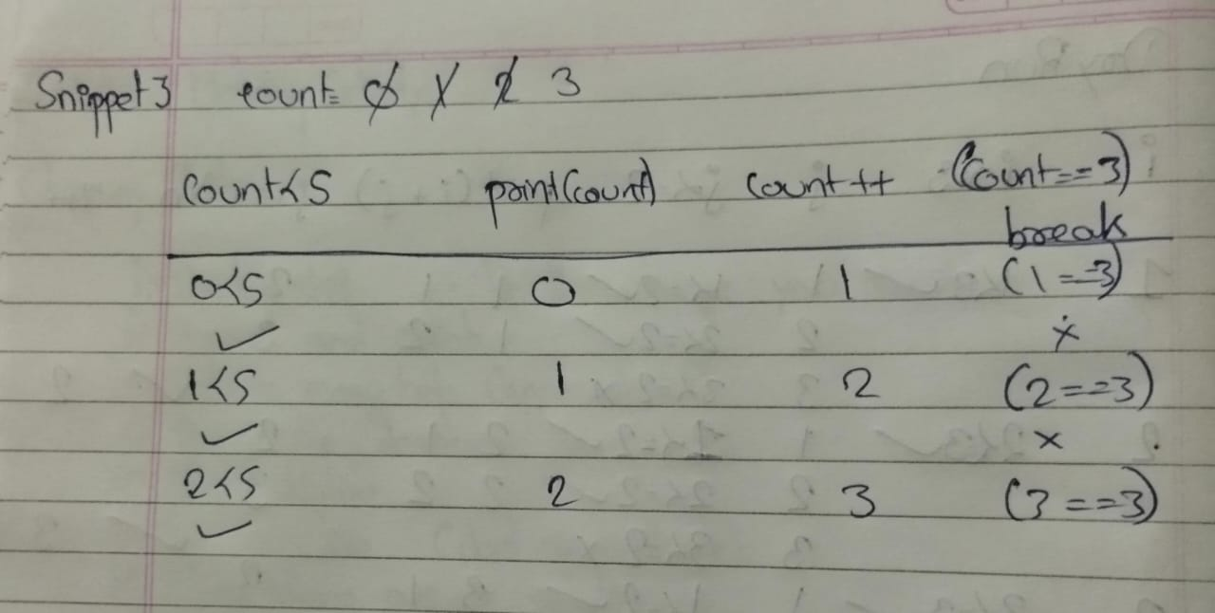

**Snippet 4:**

public class DoWhileLoop {

public static void main(String[] args) {

int i = 1;

do {

System.out.print(i + " ");

i++;

} while (i < 5);

System.out.println(i);

}

}

// Guess the output of this do-while loop.

**Output:** 1 2 3 4 5

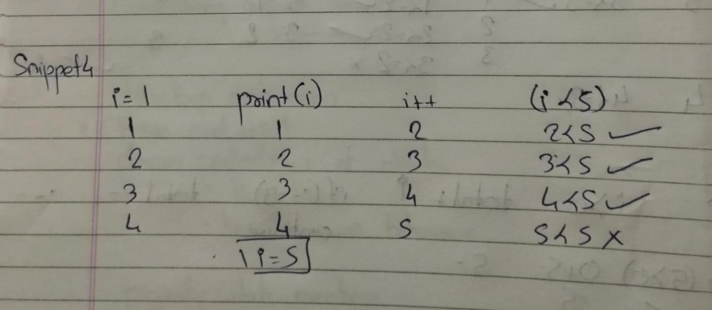

**Snippet 5:**

public class ConditionalLoopOutput {

public static void main(String[] args) {

int num = 1;

for (int i = 1; i <= 4; i++) {

if (i % 2 == 0) {

num += i;

} else {

num -= i;

}

}

System.out.println(num);

}

}

// Guess the output of this loop.

**Output:** 3

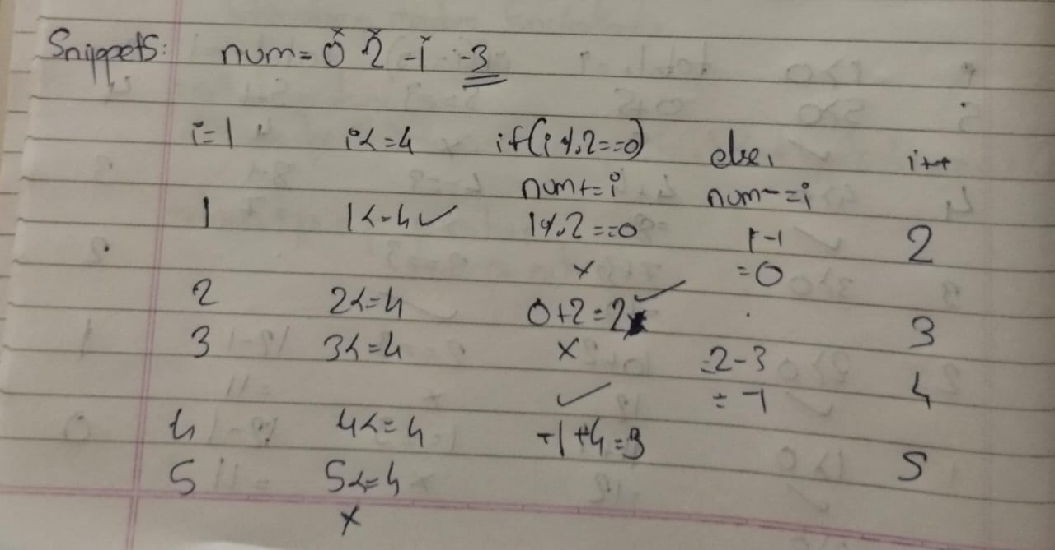

**Snippet 6:**

public class IncrementDecrement {

public static void main(String[] args) {

int x = 5;

int y = ++x - x-- + --x + x++;

System.out.println(y);

}

}

// Guess the output of this code snippet.

**Output:** 8

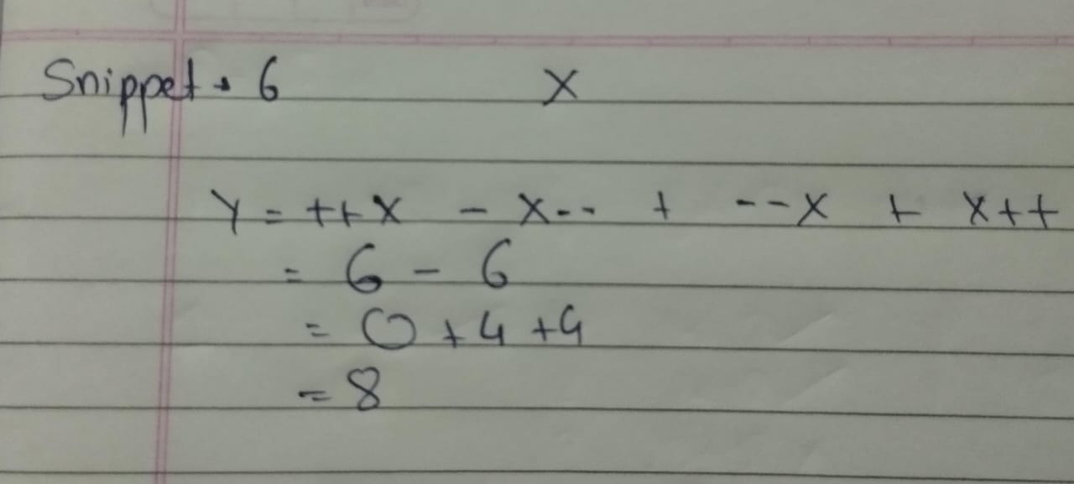

**Snippet 7:**

public class NestedIncrement {

public static void main(String[] args) {

int a = 10;

int b = 5;

int result = ++a * b-- - --a + b++;

System.out.println(result);

}

}

// Guess the output of this code snippet.

**Output:** 49

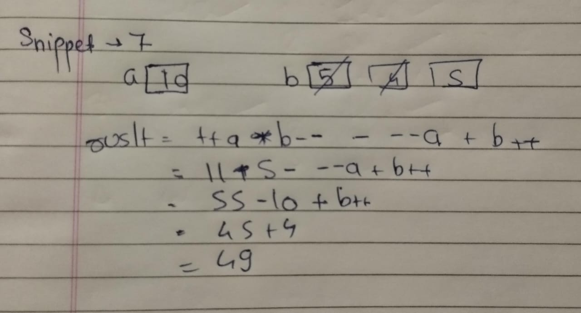

**Snippet 8:**

public class LoopIncrement {

public static void main(String[] args) {

int count = 0;

for (int i = 0; i < 4; i++) {

count += i++ - ++i;

}

System.out.println(count);

}

}

// Guess the output of this code snippet.

**Output:** -4

